Sales Operations Queries
A. KPI’s
1. Total Net Sales
select round(sum(net_sales_inr),2) as Net_Sales from sales_orders_Clean;
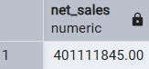

2 . Gross Profit
select round(sum(quantity * unit_price_inr),2) as Gross_Profit from sales_orders_clean;
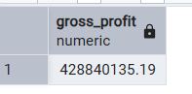

3.Total Orders
select distinct count(order_id) as Total_Oraders from sales_orders_clean;
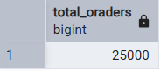
4. Total Profit
select round(sum(profit_inr),2) as Total_profit from sales_orders_clean;
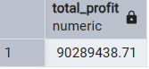
5. Avarage Order Value
select round(sum(net_sales_inr)/count(order_id),2)as Avg_Order_Value from sales_orders_clean;
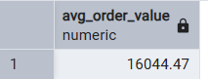
6. Profit Margin
select round((sum(profit_inr) / sum(net_sales_inr) * 100):: numeric,2) as Profit_Margin from sales_orders_clean;
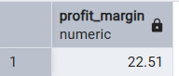

B. Monthly Trends by sales
select date_trunc('month',order_date):: date as month,
round(sum(net_sales_inr),2) as net_sales_inr,
round(sum(profit_inr),2) as profit_inr,
count(distinct order_id) as orders
from sales_orders_clean
group by 1
order by 1;
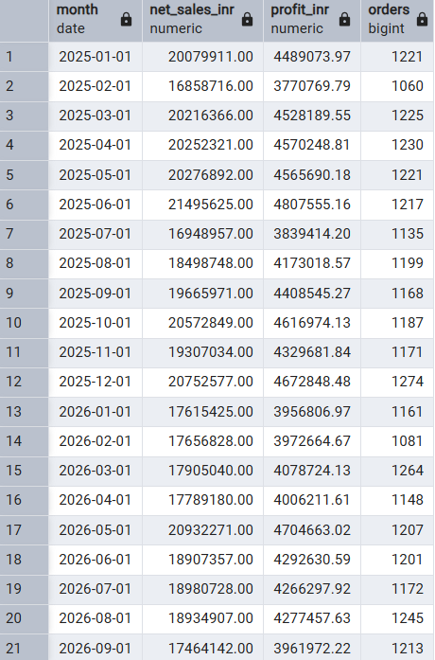
c. Region-wise performance
select region, count(distinct order_id) as orders,
round(sum(net_sales_inr),2) as net_sales_inr,
round(sum(profit_inr),2) as profit_inr,
round(100.0 * sum(profit_inr)/nullif(sum(net_sales_inr),0),2) as profit_margin_pct
from sales_orders_clean
group by region
order by net_sales_inr;
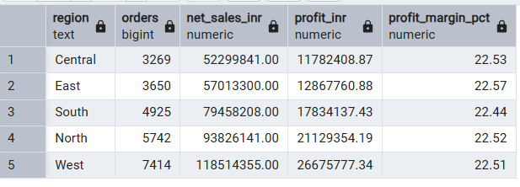
D. category performance
select product_category,sum(quantity) as unit,
round(sum(net_sales_inr),2) as net_sales_inr,
round(sum(profit_inr),2) as profit_inr
from sales_orders_clean
group by 1
order by net_sales_inr;
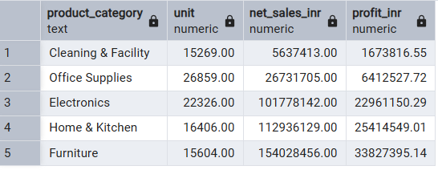

E. top 10 cities by sales
select city,count(distinct order_id) as orders,
round(sum(net_sales_inr),2) as net_sales_inr
from sales_orders_clean
group by city
order by net_sales_inr desc limit 10;

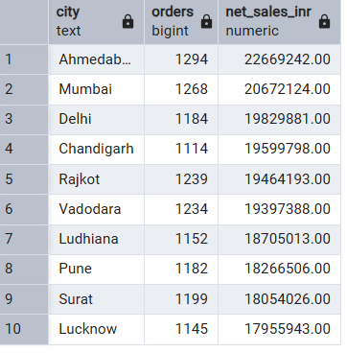
F. chennal performance
select sales_channel, count(distinct order_id) as orders,
round(sum(net_sales_inr),2) as net_sales_inr,
round(sum(profit_inr),2) as profit_inr,
round(100.0 * sum(profit_inr)/nullif(sum(net_sales_inr),0),2) as margin_pct
from sales_orders_clean
group by sales_channel
order by net_sales_inr desc;
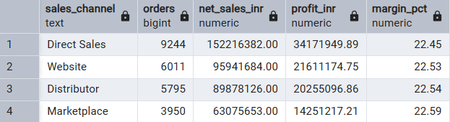

G. order status summary
select order_status, count(*) as orders,
round(sum(net_sales_inr),2) as net_sales_inr
from sales_orders_clean
group by order_status
order by net_sales_inr;
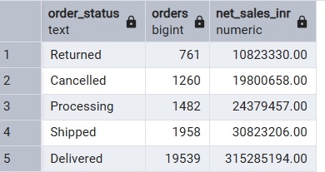
H. Discount impact
select
case when discount_pct = 0 then 'No Discount'
when discount_pct <= 0.5 then '0 - 5%'
when discount_pct <= 0.10 then '5 - 10%'
else 'above 10%' end as discount_band,
count(*) as orders,
round(sum(net_sales_inr),2) as net_sales_inr
from sales_orders_clean
group by 1 order by 1;
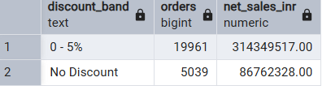
I.payment method mix
select payment_method, count(*) as orders,
round(sum(net_sales_inr),2) as net_sales_inr
from sales_orders_clean
group by payment_method
order by net_sales_inr;
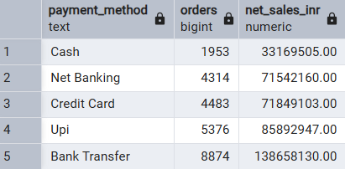
J. top customers
select customer_name, count(*) as orders,
round(sum(net_sales_inr),2) as net_sales_inr,
round(sum(profit_inr),2) as profit_inr
from sales_orders_clean
group by customer_name
order by net_sales_inr desc limit 10;
